**Exception and Error Handling QEA**

1. **What are different types of Access modifiers?**

**Default**- when no access modifier is mentioned

**Private**- Only with in the class they declared

**Protected**- Within same package /sub class in different package

**public**-From every where in the program

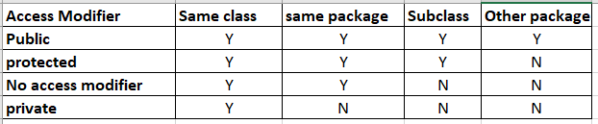

1. **What is different between Exception and error ?**

**Exception**

An exception is an undesirable or unexpected event,which occurs during the execution of a program i.e at run time that disrupts the normal flow of program’s instructions. It can be handled by our program

**Error**

An error is a very severe problem which cant be handled by a program. Example : when your computer runs out of space, there is nothing our program can do except crashing.

1. **What is different between Checked Exception and UnChecked Exception?**

**Checked Exceptions**

A checked exception is the one that the compiler checks or notifies during compilation.

Checked Exceptions are also known as compile-time exceptions.

These exceptions cannot be ignored.

If a code within a function throws a checked exception, the function must handle the exception or specify it using the throws keyword.

**Unchecked Exceptions**

An unchecked exception occurs during the execution process.

Unchecked Exceptions are also known as runtime exceptions.

Programming mistakes, such as logic errors or improper use of an API, are examples of this.

Runtime exceptions are ignored during compilation.